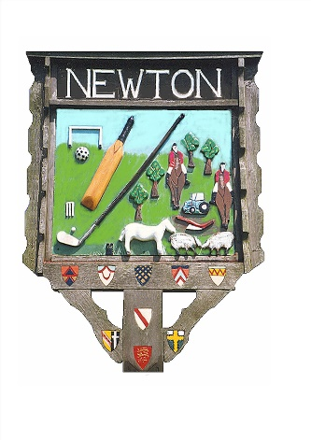
Newton Green Trust

Newton Green Trust notice of meeting.

Tuesday 24th February 2026, 7.30PM, Village Hall

Agenda

- Apologies for absence
- Declarations of interest
- Agree minutes of previous meeting
- Public Forum (15 minutes)
- Correspondence
    - Parish Council request for grant
- Golf Club Report
- Treasurers Report

Exclusion of the public due to confidential nature of discussions for the following items.

- Land issues/licenses/easements
- Golf Club fairway realignment proposal
- AOB
- Date of next meeting

